**Exp9: Configuration of Network address translation in Cisco packet tracer and verify the configuration**

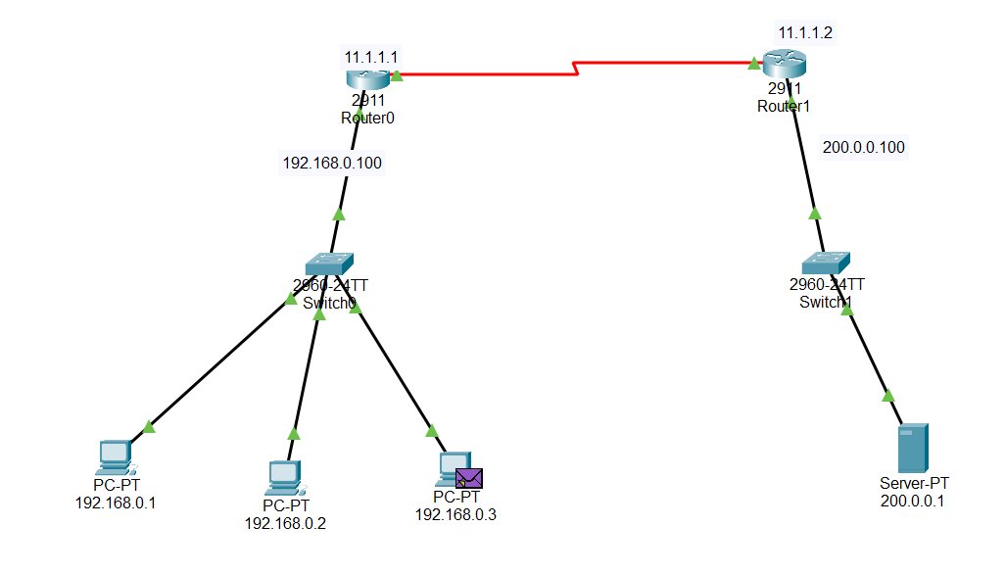

**Router 0**

Router>enable

Router#

Router#configure terminal

Router(config)#interface GigabitEthernet0/0

Router(config-if)#ip address 192.168.0.100 255.255.255.0

Router(config-if)#no shutdown

Router(config-if)#exit

Router(config)#interface Serial0/3/0

Router(config-if)#no shutdown

Router(config-if)#ip address 11.1.1.1 255.0.0.0

Router(config-if)#ip address 11.1.1.1 255.0.0.0

Router(config-if)#

%LINK-5-CHANGED: Interface Serial0/3/0, changed state to up

%LINEPROTO-5-UPDOWN: Line protocol on Interface Serial0/3/0, changed state to up

Router(config-if)#exit

Router(config)#ip route 0.0.0.0 0.0.0.0 11.1.1.2

Router(config)#interface g0/0

Router(config-if)#ip nat inside

Router(config-if)#exit

Router(config)#interface serial 0/3/0

Router(config-if)#ip nat outside

Router(config-if)#exit

Router(config)#access-list 50 permit 192.168.0.0 0.0.0.255

Router(config)#ip nat pool publicip 50.0.0.1 50.0.0.50 netmask 255.255.255.0

Router(config)#ip nat inside source list 50 pool publicip

Router(config)#exit

Router#

%SYS-5-CONFIG_I: Configured from console by console

Router#

**Router 1**

Router>enable

Router#

Router#configure terminal

Enter configuration commands, one per line. End with CNTL/Z.

Router(config)#interface GigabitEthernet0/0

Router(config-if)#ip address 200.0.0.100 255.255.255.0

Router(config-if)#no shutdown

Router(config-if)#

Router(config-if)#exit

Router(config)#interface Serial0/3/0

Router(config-if)#ip address 11.1.1.2 255.0.0.0

Router(config-if)#no shutdown

Router(config-if)#exit

Router(config)#ip route 50.0.0.0 255.0.0.0 11.1.1.1

